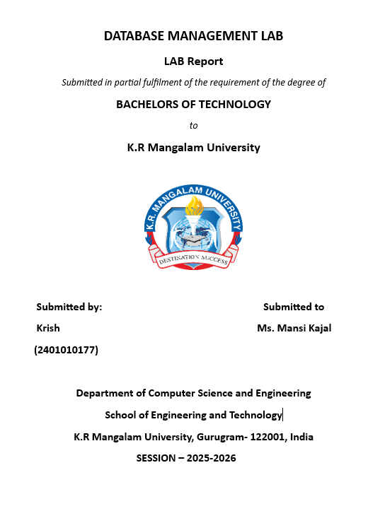

LAB ASSIGNMENT – 2

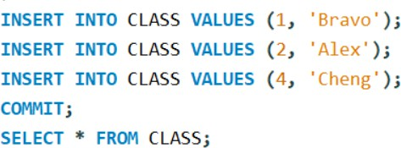
Objective:
To understand and implement SQL transactions using COMMIT, SAVEPOINT, and
ROLLBACK, retrieve records using SELECT queries, and perform INSERT, UPDATE, and ALTER operations on tables.
Table Structures:

CLASS
D (NUMBER) and Name (VARCHAR).
The initial records in the table are (1, 'Bravo'), (2, 'Alex'), and (4, 'Cheng').

EMPLOYEES
Employee_Id (NUMBER), First_Name (VARCHAR), Last_Name (VARCHAR), Email (VARCHAR), Phone_Number (VARCHAR), Hire_Date (DATE), Job_Id (VARCHAR), Salary (NUMBER),
Commission_Pct (NUMBER), Manager_Id (NUMBER), and Department_Id (NUMBER).

DDL Questions (Data Definition Language):
1. How do you create a table named CLASS with appropriate data types?
STEP 1 – FIRST WE CREATE DATABASE .
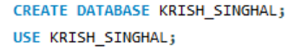
STEP 2 – THEN WE CREATE TABLE.
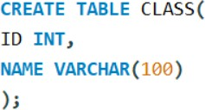

STEP 3 – THEN WE INSERT DATA INTO THE TABLE.

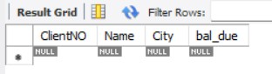
OUTPUT:
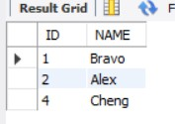
- How do you create a table named EMPLOYEES with the specified attributes?
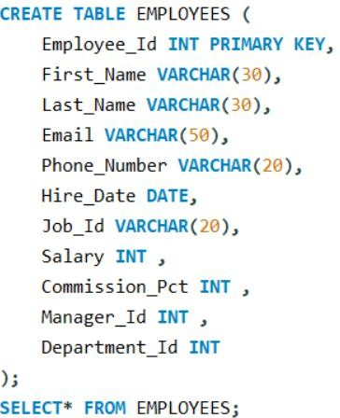

OUTPUT:
- How do you create a table named Client_master with the specified attributes?
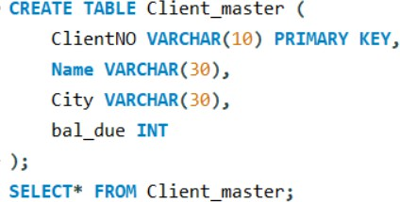

OUTPUT :

- What SQL statement would you use to rename the table Client_master to Client12?
- How do you display the bal_due column heading as “BALANCE”?

OUTPUT :
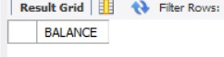

DML Questions (Data Manipulation Language):
Part A: Transactions and Savepoints (CLASS Table)
Give the output of the following SQL script:
INSERT INTO class VALUES (5,’Rahul’); COMMIT;
UPDATE class SET name = ‘Abhijeet’ WHERE id=’5’; SAVEPOINT A;
INSERT INTO class VALUES (6,’Chris’); SAVEPOINT B;
INSERT INTO class VALUES (7,’Bravo’); SAVEPOINT C;
SELECT * FROM class;
ROLLBACK TO B;
SELECT * FROM class;
ROLLBACK TO A;
  - INSERT INTO class VALUES (5,’Rahul’); COMMIT;
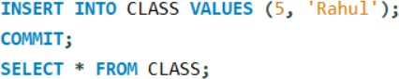

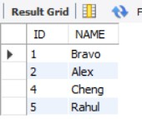
  - UPDATE class SET name = ‘Abhijeet’ WHERE id=’5’;
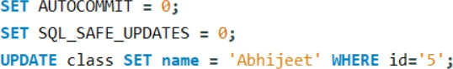

OUTPUT :
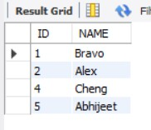

  - SAVEPOINT A;
  - INSERT INTO class VALUES (6,’Chris’); SAVEPOINT B;
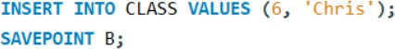

OUTPUT :
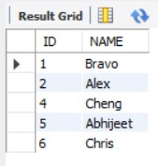

  - INSERT INTO class VALUES (7,’Bravo’); SAVEPOINT C;

SELECT * FROM class;

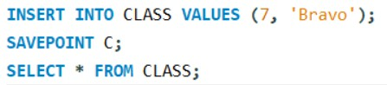
OUTPUT :
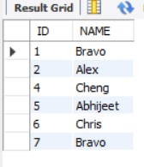
  - ROLLBACK TO B;
SELECT * FROM class;
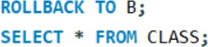

OUTPUT :
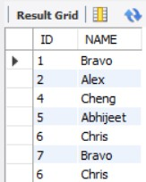

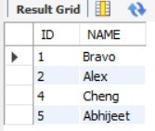
  - ROLLBACK TO A;
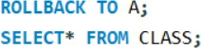
OUTPUT :

Part B: Retrieving Records (EMPLOYEES Table)
    - Find out the employee id, names, and salaries of all the employees..
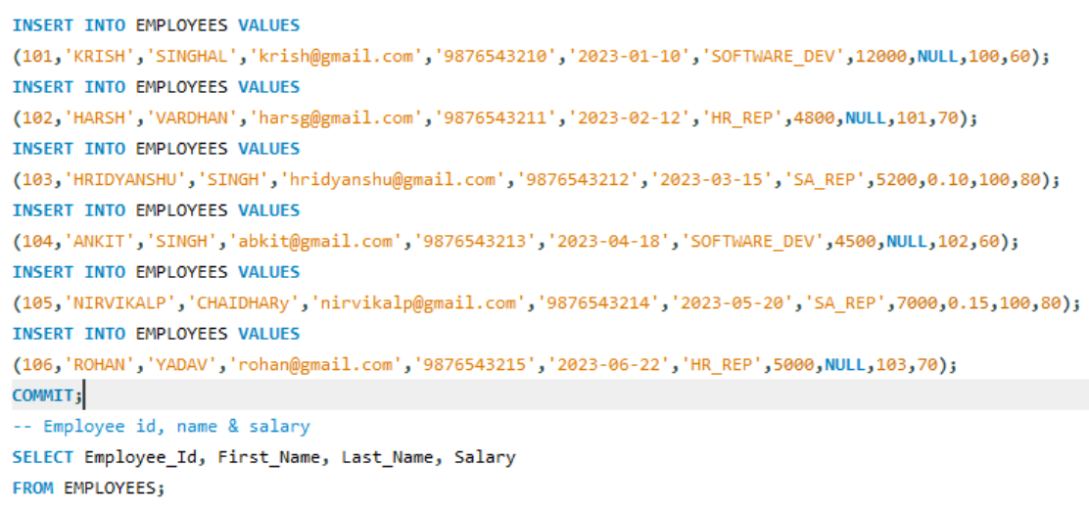

OUTPUT :
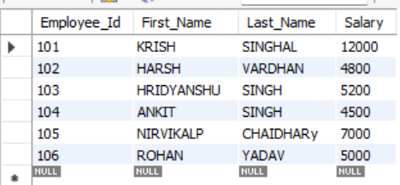
    - List out the employees who work under manager 100.
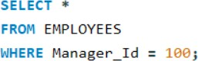

OUTPUT:

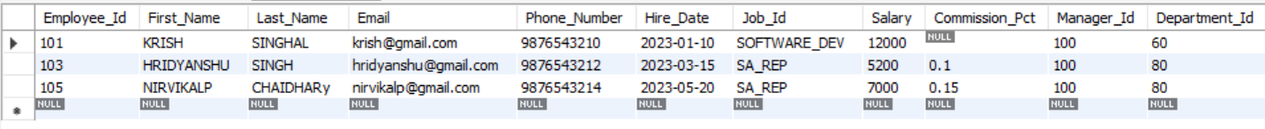
    - Find the names of the employees who have a salary greater than or equal to 4800.
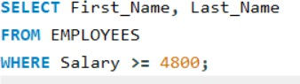

OUTPUT :
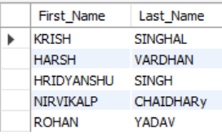
    - List out the employees whose last name is ‘AUSTIN’.
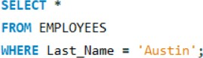

OUTPUT :
    - Find the names of the employees who work in departments 60, 70, and 80.
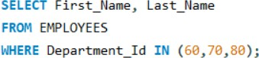

OUTPUT :

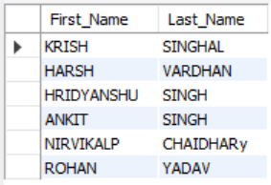
    - Display the unique Manager_Id.
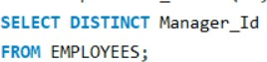

OUTPUT :
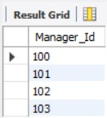

Part C: Updating Records (Client_master Table)
- Insert five records into the Client_master table.
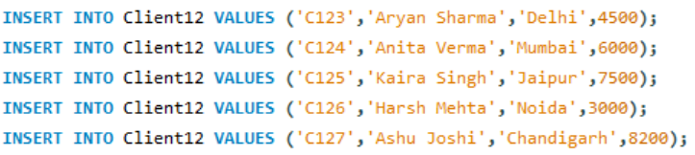

OUTPUT :
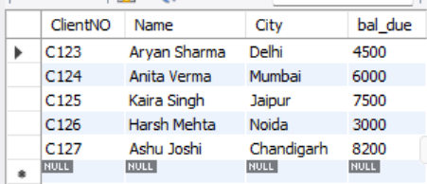

- Find the names of clients whose bal_due > 5000.
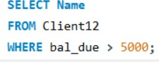

OUTPUT :
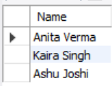
- Change the bal_due of ClientNO "C123" to Rs. 5100.

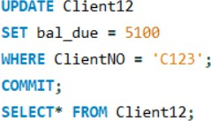

OUTPUT :
